BITS PILANI DIGITAL
FIRST TRIMESTER 2025-26
ADVANCED APEX PROJECT 1
Project Title | Airline Passenger Demand Forecasting Project
Supervisor Name | Ayushi Garg
Name of the Learner (with BITS ID) | Name of the Learner BITS ID  Sree Nihitha Chennupati 2025EM1100344  Suryakantha VishnuPriya Ravada 2025EM1100010  Purnananda Surya Tarun Bandaru 2025EM1100081  Hemanth Chand Gudivada 2025EM1100165

Courses Relevant for the Project & Corresponding Trimester
Sl. No. | Subject Name | State the relevance to Project
1 | Statistical Modelling & Inferencing | Used statsmodel to perform seasonal decomposition and the Augmented Dickey-Fuller test for stationarity, which are core inferential steps before modeling.
2 | Data Pre-processing | Loaded the CSV, converted data_date to datetime objects, handled missing values using .dropna() , and resampled the time-series to a monthly frequency (MS).
3 | Feature Engineering | Created new predictive features for ML models, including lag features (.shift() ), rolling means (.rolling().mean()), and date components (month and year).
4 | Data Visualization & Storytelling | Used Matplotlib and Seaborn to plot the main time-series, seasonal decomposition, data distributions (histogram/boxplot), and a feature correlation heatmap.
5 | Data Stores & Pipelines | Justification (Not Applicable): This project focuses on in-memory analysis and modeling from a single CSV file, so complex data stores or pipelines were not required.

Airline Passenger Demand Forecasting Project

1. Project Statement
Airlines and aviation authorities require accurate forecasts of international passenger demand to optimize resource allocation, scheduling, pricing, and long-term planning. Using historical passenger and departures data, this project aims to build predictive models that forecast future passenger traffic at a monthly level.

2. Business Goal
- Primary Goal: Forecast monthly international passenger demand for the next 12–24 months.
- Why it matters:
  - Helps airlines adjust flight schedules and fleet utilization.
  - Supports airports in planning gate/crew resources and infrastructure.
  - Assists governments and tourism boards in anticipating travel demand.
- Success Criteria: Models achieve ≤10% MAPE on holdout forecasts and generate stable, interpretable forecasts for decision-making.

3. Data Sources
(https://drive.google.com/file/d/1eFohZDR_M-pgs7MZUHbn04m-KuQoB88o/view?usp=share_link)
  - Contains monthly passenger counts by airport and world region.
  - Time coverage: 1990–2020.
(Both datasets come from U.S. Bureau of Transportation Statistics / FAA reporting — though you uploaded local copies from kaggle.)
https://www.kaggle.com/datasets/parulpandey/us-international-air-traffic-data

4. Tools & Technologies
- Programming: Python
- Libraries:
  - pandas, numpy → Data wrangling & aggregation
  - matplotlib, seaborn → Data visualization
  - statsmodels → SARIMAX (time-series forecasting)
  - scikit-learn → Regression (RandomForest, feature engineering)
- Workflow/Environment: Jupyter Notebook / Google Colab
- Version Control: Git/GitHub
- Power BI : Interactive dashboards

5. Project Workflow
- Problem Definition → Identify forecasting need & business requirements.
- Data Extraction → Load CSV datasets into pandas, parse dates, clean missing values.
- Exploratory Data Analysis (EDA):
  - Trend/seasonality analysis of passenger counts.
  - Airport-level vs aggregate analysis.
- Feature Engineering:
  - Time features (month, year).
  - Lag features (1, 2, 3, 6, 12 months).
  - Rolling means (short-term vs long-term demand).
- Modeling:
  - ML approach: RandomForest regression with engineered features.
  - Compare performance on holdout (last 24 months).
- Model Evaluation:
  - Metrics: MAE, RMSE, MAPE.
  - Visual comparison of predicted vs actual passengers.
- Forecasting & Deployment:
  - Generate 12–24 month forecasts.
  - Save outputs as CSV/dashboard for stakeholders.

6. Data Extraction (PHASE1_TEAMBLACK.ipynb)
- Source: Kaggle (https://www.kaggle.com/datasets/parulpandey/us-international-air-traffic-data?select=International_Report_Passengers.csv )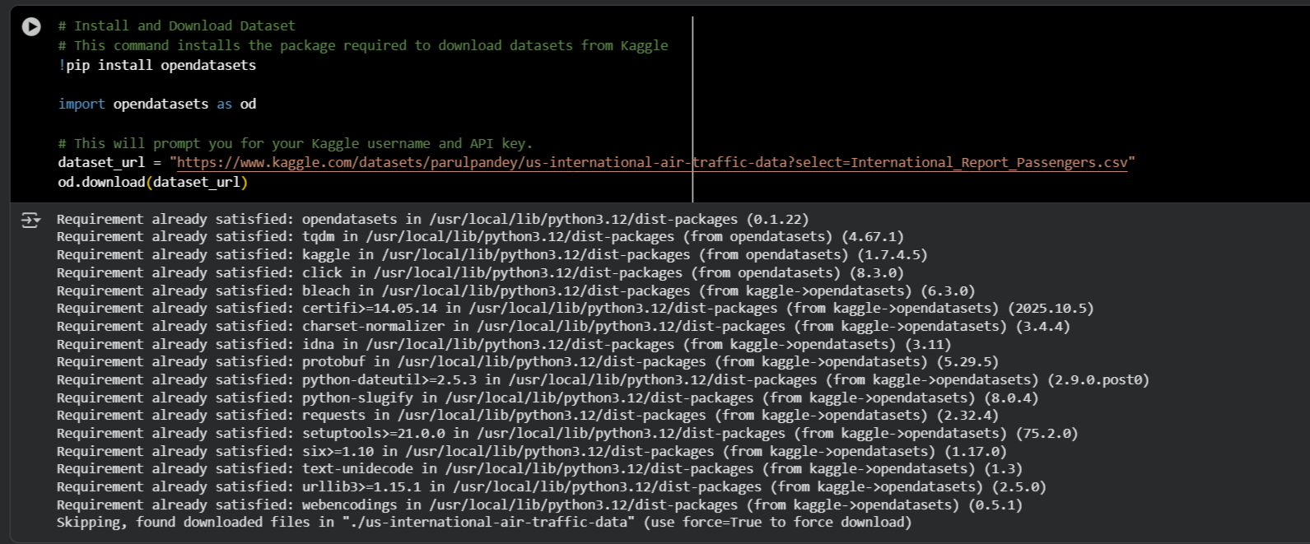
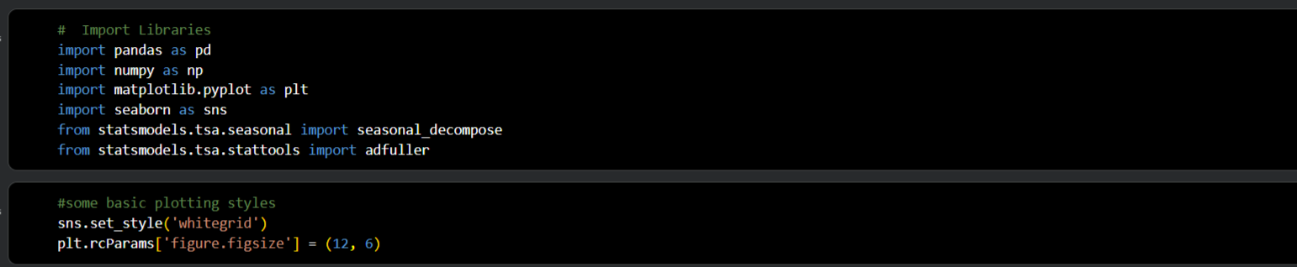

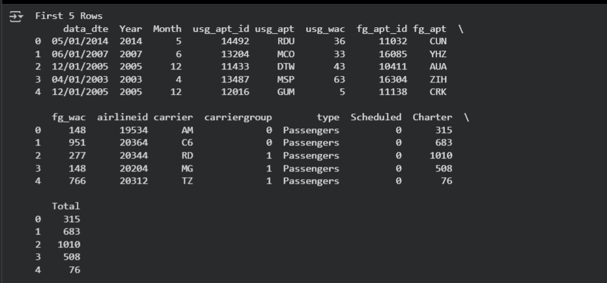
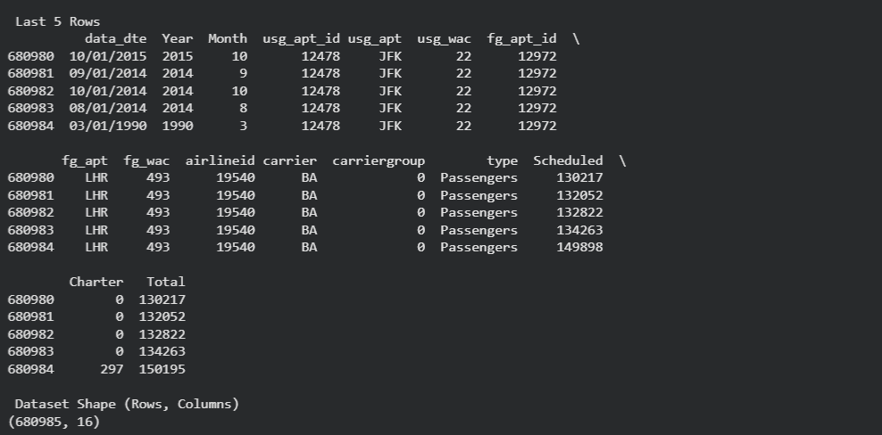
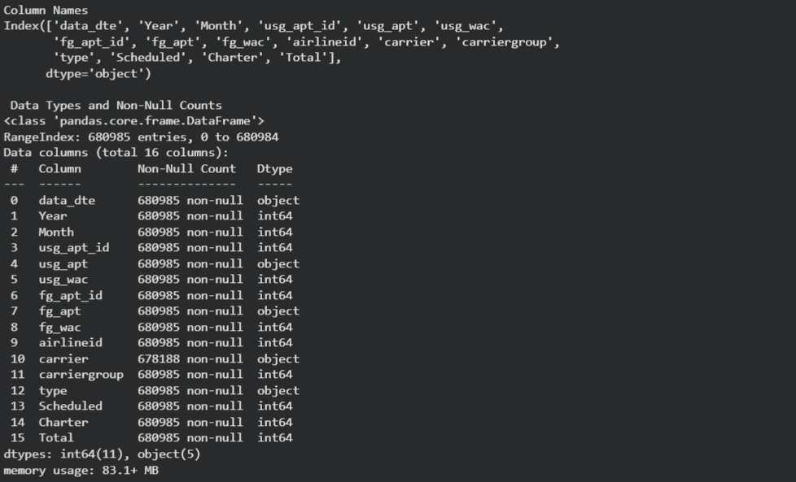
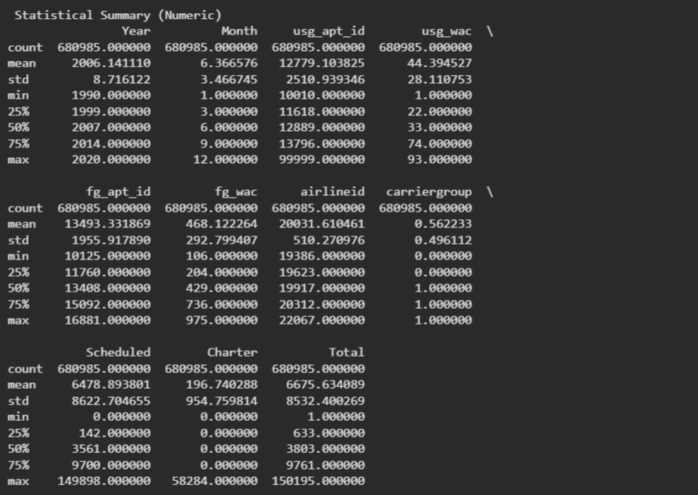
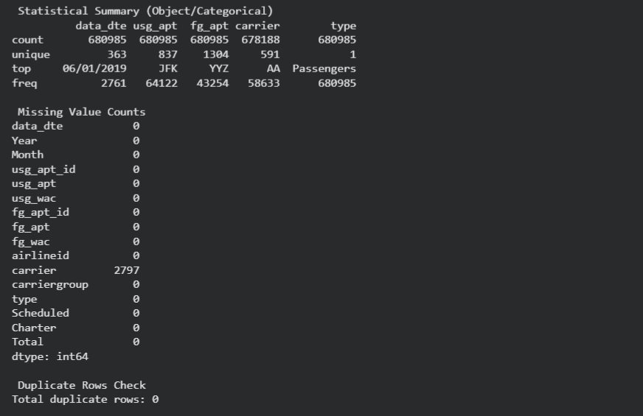
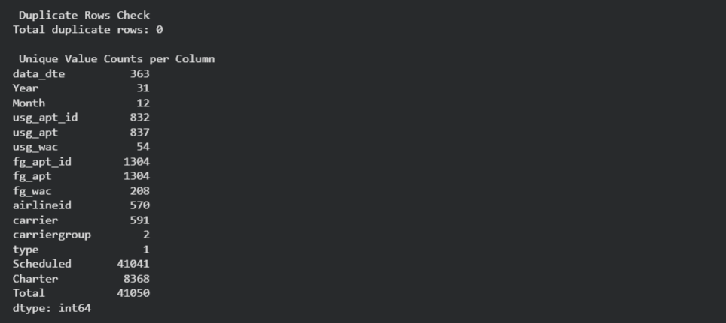
- Transformation:
  - Convert date column to monthly frequency.
  - Aggregate passenger counts across all airports to get total monthly demand.
  - Similarly, aggregate departures if needed for exogenous features.
7. Data Dictionary (https://docs.google.com/spreadsheets/d/1eyzytou5PB7NHTKUgQu-oUWdgeiWd4C87XbZS6h3GoY/edit?usp=share_link)
Feature name | Data Type | Description
data_dte | Date | The full date of the record.
Year | int64 | The year the flight data was recorded.
Month | int64 | The month the flight data was recorded (1-12).
usg_apt_id | int64 | A unique identifier for the U.S. gateway airport.
usg_apt | String | The 3-letter IATA code for the U.S. gateway airport (e.g., JFK, LAX).
usg_wac | int64 | The World Area Code (WAC) for the U.S. airport. This code represents a geographical area.
fg_apt_id | int64 | A unique identifier for the foreign gateway airport.
fg_apt | String | The 3-letter IATA code for the foreign gateway airport (e.g., LHR, CUN).
fg_wac | int64 | The World Area Code (WAC) for the foreign airport.
airlineid | int64 | A unique identifier for the airline.
carrier | String | The 2-letter code for the airline carrier (e.g., BA for British Airways).
carriergroup | int64 | A numerical code representing the airline's operational group.
type | String | The type of data being reported. In this dataset, it is 'Passengers'.
Scheduled | int64 | The number of passengers on regularly scheduled flights.
Charter | int64 | The number of passengers on non-scheduled charter flights.
Total | int64 | The total number of passengers, which is the sum of Scheduled and Charter passengers.
(Main column for forecasting = passengers.)

